1. Create a MariaDB Engine based RDS Database.

2. Connect to the DB using the following ways:

a. SQL Client for Windows

b. Linux based EC2 Instance

1)Create a MariaDB Engine based RDS Database.

RDS >database > create database >

Choose a database creation method > Standard create

Engine options **>** MariaDB

Engine Version > latest ( 10.11.6)

Templates > free tier

DB instance identifier > name (mydb)

Credentials Settings > master username and password (admin n password)

Credentials management > self managed

Instance configuration > db.t3.micro

Storage > default

Storage autoscaling > no

Connectivity > no instance ( I will create instance later )

Vpc > default

Availability Zone > us-eat-1a

Public access > yes

VPC security group  > crate new (sgformydb)

Database options > Initial database name ( student)

Rest all keep default and create

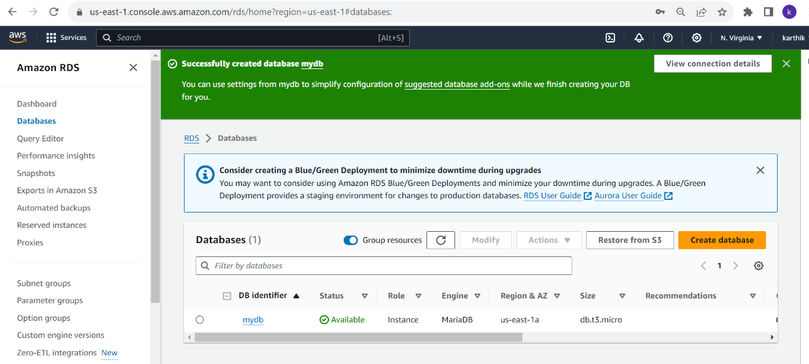

2. Connect to the DB using the following ways:

a. SQL Client for Windows

b. Linux based EC2 Instance

1. Created sg and ec2 instance

Sg ( ssh & mysql/ Aurora form any where) - sg for ec2

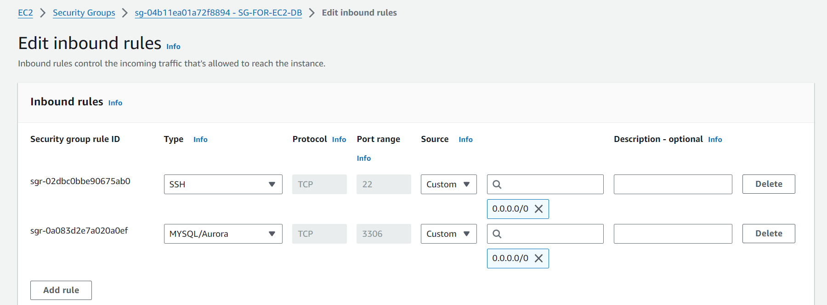

Sg of db ( create sg chain with ec2 sg)

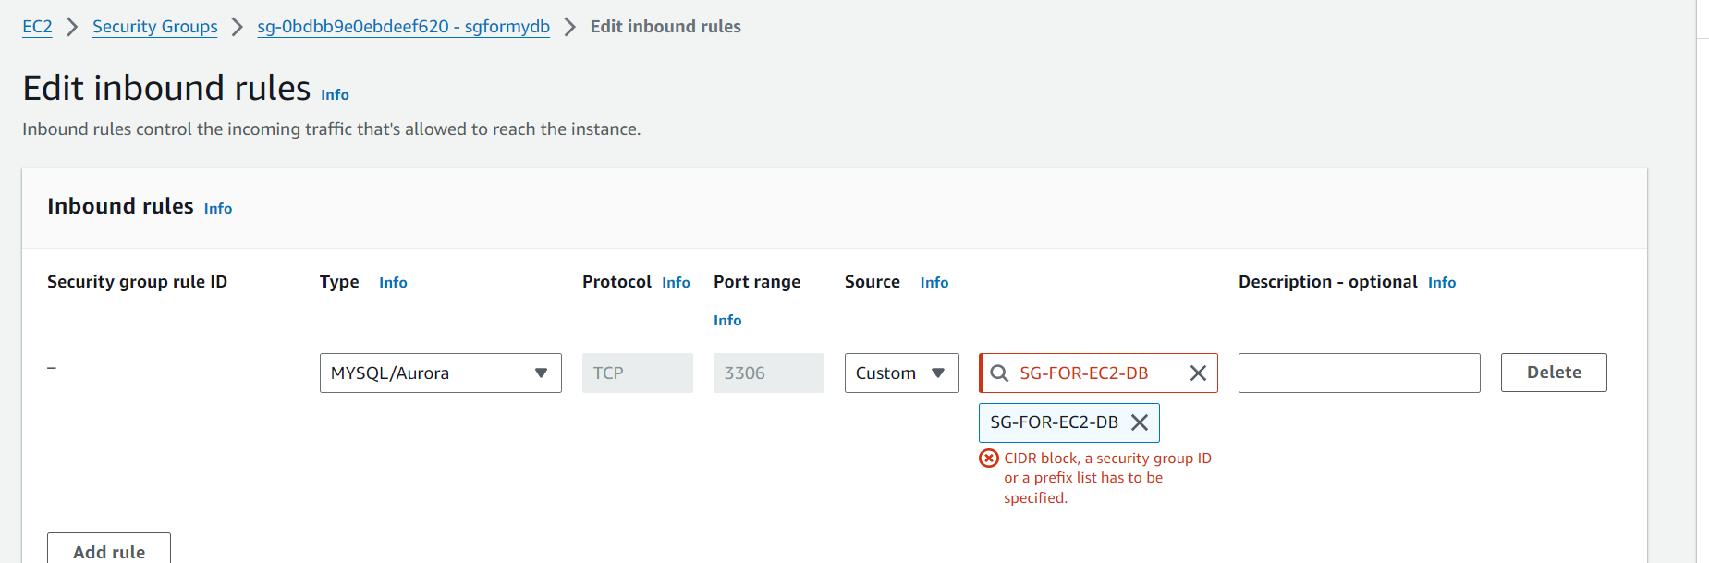

1. Create ec2 instance using ec2 sg

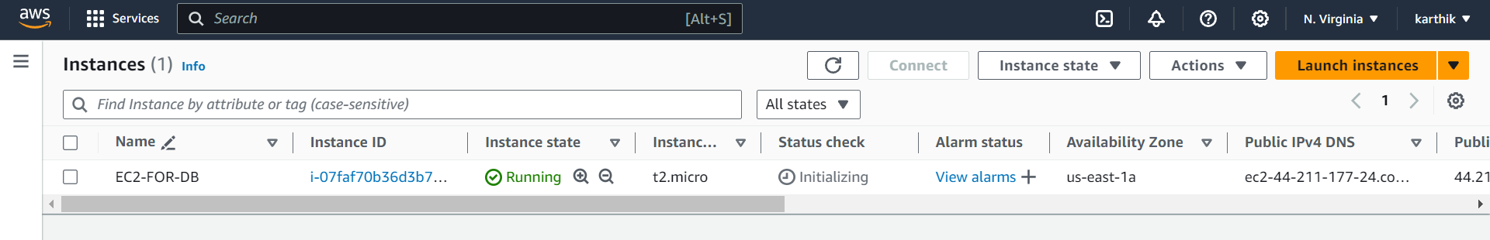

a. SQL Client for Windows

to connect via sql Clint for windows

1. Download DB brave sql Clint

Go to database > new database connection > search for MariaDB engine

In server host > give db endpoint DNS (mydb.cts6ye8wo1op.us-east-1.rds.amazonaws.com)

Port (3306)

User name (admin) and password (Mydb2024)

Connected to sql client in windows > can see data base student created in Linux ec2 mysql

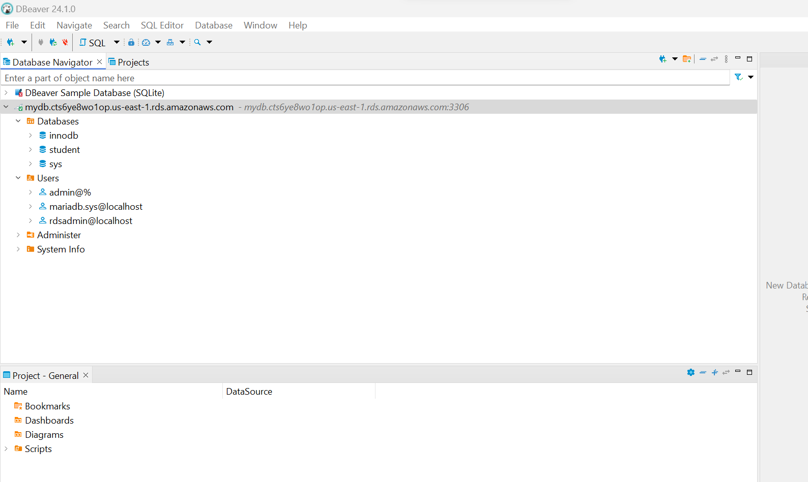

b. Linux based EC2 Instance

>connect to instance

> install MariaDB Clint -- sudo dnf update -y

--sudo dnf install mariadb105

.> connect to db -- mysql -h mydb.cts6ye8wo1op.us-east-1.rds.amazonaws.com-P 3306 -u admin -p

